**Year 10 Physics End of Topic Test**

**Name: \_\_\_\_\_\_\_\_\_\_\_\_\_\_\_\_\_\_\_\_\_\_\_\_\_\_\_ /39**

**Formula you may need**

[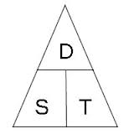](http://www.google.com.au/url?sa=i&rct=j&q=speed%20distance%20time%20triangle&source=images&cd=&cad=rja&docid=l-Td1q_Q0MI0IM&tbnid=cC1NHwB6_ZXB3M:&ved=0CAUQjRw&url=http://www.skoool.co.za/studynotes/maths/id270.htm&ei=haIRUr72K8GHkQX8qoHACw&psig=AFQjCNFf-ofXYSPuXljl_uBwHvbcdC6D5A&ust=1376973815450016)[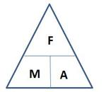](http://www.google.com.au/url?sa=i&rct=j&q=force+mass+acceleration+triangle&source=images&cd=&cad=rja&docid=O6V53PkQA165NM&tbnid=vhNrW-efYEJTlM:&ved=0CAUQjRw&url=http://jdevlin.pottsgrove.wikispaces.net/Physics+Tasks+2012&ei=z6IRUqS2NYyXkgXUoIDwCg&psig=AFQjCNGaoVG_TT9V-bDQMdMZk8qwyYJa6Q&ust=1376973888721903)

[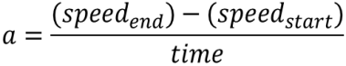](http://www.google.com.au/url?sa=i&rct=j&q=formula+acceleration&source=images&cd=&docid=n1BQvXMu3V1gnM&tbnid=tyy5e7co4fxZgM:&ved=0CAUQjRw&url=http://www.etorgerson.net/WebPages/ScienceUnits/A04_Acceleration.html&ei=ivH1UbrJMIiPkwW0pYD4Bg&psig=AFQjCNGKaO8mY3zS4cauOZdzzpsrQErjaw&ust=1375159034805046)

W= Fxd

P= W/t

**Multiple Choice Answer Sheet – Select ONE answer for each**

1. A B C D

2. A B C D

3. A B C D

4. A B C D

5. A B C D

6. A B C D

7. A B C D

8. A B C D

9. A B C D

10. A B C D

11. A B C D

12. A B C D

13. A B C D

14. A B C D

15. A B C D

16. A B C D

17. A B C D

18. A B C D

19. A B C D

20. A B C D

[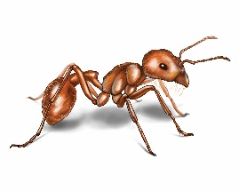](http://www.google.com.au/url?sa=i&rct=j&q=ant&source=images&cd=&cad=rja&docid=xnY1A86yla2paM&tbnid=RzulS6ugMKx4fM:&ved=0CAUQjRw&url=http://www.orkin.com/ants/harvester-ant/&ei=dZs7UrXWFNDDkAWDrIHoDA&psig=AFQjCNH_SG2m2KFbnhWkRaDTwREnye2S-g&ust=1379724529024052)**1** What distance would an ant, crawling at a speed of 2 centimetres per second, cover in an hour? (Distance = Speed x Time)

A 120 cm

B 7200cm

C 1200m

D 7200m

**2** The correct definition for work is?

A The energy required to perform a task.

B The rate at which energy is used.

C The relationship between a force and distance.

D Two unbalanced forces acting on an object.

[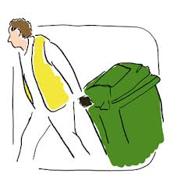](http://www.google.com.au/url?sa=i&rct=j&q=put+out+wheely+bin&source=images&cd=&cad=rja&docid=29pzR1WcQ3u_eM&tbnid=3Co3y0nBE_mw2M:&ved=0CAUQjRw&url=http://www.oxfordshire.gov.uk/cms/content/rubbish-and-recycling-oxfordshire&ei=g9A7UsKpCIKIkwWw6YH4Dg&psig=AFQjCNGHJ3ZxsU6cRHbs3zRqdJid1aroRw&ust=1379738041806358)**3** Chris applies a 90 N to a 65 kg bin. The bin will accelerate at: $(A=\frac{Force}{Mass} )$

A 0.138 m/s2

B 1.38 m/s2

C 5850 m/s2

D 58.5 m/s2

**4** Power is the rate at which energy is supplied. What power is needed to supply 6000 J to lift a 15kg child 10 m up a vertical cliff face in 5 seconds? $\left(Power= \frac{Work}{Time}\right)$

A 1200 J/s

B 120 J/s

C 300 000 J/s

D 30 000 J/s

**5** Look at the three pieces of ticker tape below, labelled A, B and C.

Choose the answer that explains each piece correctly.

[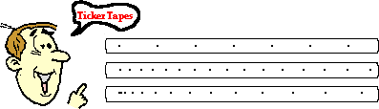](http://www.google.com.au/url?sa=i&rct=j&q=ticker+tape+speed&source=images&cd=&cad=rja&docid=wMhrNsjROP9a0M&tbnid=vzACHjSPZdrteM:&ved=0CAUQjRw&url=http://www.nileswestils.com/ILS/Acceleration.html&ei=-tA7UrGqKIfdkgXOt4HIBA&psig=AFQjCNH19iGDLCD5X9W_FaHQYkKvniD58g&ust=1379738197384806)

**A**

**B**

**C**

|  |  |  |  |
| --- | --- | --- | --- |
|  | Piece A | Piece B | Piece C |
| A | Decelerating | Maintaining a constant speed | Accelerating |
| B | Maintaining a constant speed | Accelerating | Decelerating |
| C | Accelerating slowly | Maintaining a constant speed | Decelerating |
| D | Maintaining a constant Speed | Accelerating Slowly | Accelerating faster |

**6** To convert joules to kilojoules you:

A multiply the joules by 1000.

B divide the joules by 1000.

C multiply the kilojoules by 1000.

D divide the kilojoules by 1000.

**7** An aircraft is flying in a straight line at constant altitude and at a constant speed. What can be said about the forces on the aircraft?

A The forces are unbalanced.

B The forces are balanced.

C The forces are compression forces.

D The aircraft is accelerating.

**8** Which of Newton’s Laws of Motion involve inertia:

A Newton’s First Law of Motion

B Newton’s Second Law of Motion

C Newton’s Third Law of Motion

D All of the above

**9** Which of the following statements best describes the “net Force” on an object?

A The sum of all the forces

B The difference between the biggest and smallest forces

C Multiplying all forces together

D None of the above

**10** Newton realised that forces always occur in:

A balanced parts

B unbalanced parts

C sequences

D pairs

**[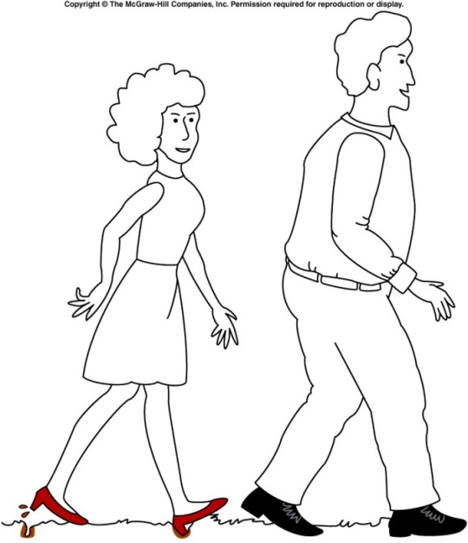](http://www.google.com.au/url?sa=i&rct=j&q=pressure+high+heel&source=images&cd=&cad=rja&docid=nxP8BgFtQrkhwM&tbnid=dVIUZoWEAPzlTM:&ved=0CAUQjRw&url=http://onlinephys.com/pressure.html&ei=hfU3Uoq9C8WfkwW2toHQAg&psig=AFQjCNGIEB4RESz64D3f84yVrSv_95GNLw&ust=1379485420790197)11** Which of the following is **true** about the diagram of the man and woman walking?

A The woman is making marks in the ground because she is placing more force on the grass

B The man is not making any marks on the ground because he is placing less force on the grass

C The woman is making marks on the ground because her shoes have less area touching the ground

D The man’s shoes are not making any marks on the ground because his have less area touching the ground

**12** Which of the following is the correct definition of work?

A The energy used when performing a task.

B The energy transferred by a force that acts over a distance.

C The amount of potential energy stored in an object.

D The impact of a force when energy is used.

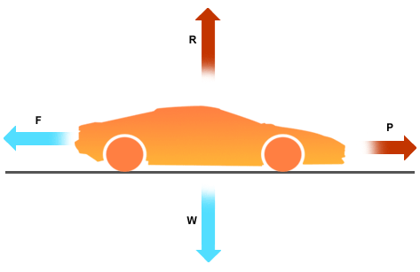

**13** Which of the following is **correct** about the movement of the car?

A The car is still

B The car is at a constant speed

C The car is accelerating

D The car is decelerating

**14** What is work measured in?

A Joules

B Watts

C Kilojoules

D Kilowatts

**15** Leslie runs a race that starts and finishes at the same point. If the race was 1000 metres, what was Leslie’s displacement at the end of the race?

A 1000 metres

B 500 metres

C 10 metres

D 0 metres

[](http://www.google.com.au/url?sa=i&rct=j&q=force+mass+acceleration+triangle&source=images&cd=&cad=rja&docid=O6V53PkQA165NM&tbnid=vhNrW-efYEJTlM:&ved=0CAUQjRw&url=http://jdevlin.pottsgrove.wikispaces.net/Physics+Tasks+2012&ei=z6IRUqS2NYyXkgXUoIDwCg&psig=AFQjCNGaoVG_TT9V-bDQMdMZk8qwyYJa6Q&ust=1376973888721903)**16** These variables relate to which of Newton’s Laws of Motion?

A Newton’s First Law

B Newton’s Second Law

C Newton’s Third Law

D All three of the Laws of Motion

1. **17**  Which of the following stick people would be unstable and most likely to topple over?

|  |  |  |  |
| --- | --- | --- | --- |
| A | PSCI_10PR_9_12Ta | B | PSCI_10PR_9_12Tb |
| C | PSCI_10PR_9_12Tc | D | PSCI_10PR_9_12Td |

**18.** Look at the data in this table.

|  |  |
| --- | --- |
| Type of car | Time taken to reach 100km/h from rest (minutes) |
| Ariel Atom V8 | 2.5 |
| Nissan GTR | 3 |
| [Lamborghini Aventador](http://news.drive.com.au/drive/motor-news/first-drive-lamborghini-aventador-20110602-1fhci.html) | 2.9 |

Of the cars in the table above which has the fastest acceleration?

(a) Ariel Atom V8.

(b) Nissan GTR.

(c) Lamborghini Aventador.

(d) This question cannot be answered with the information in the table.

*Questions 19 and 20 refer to the diagram on the right:*

*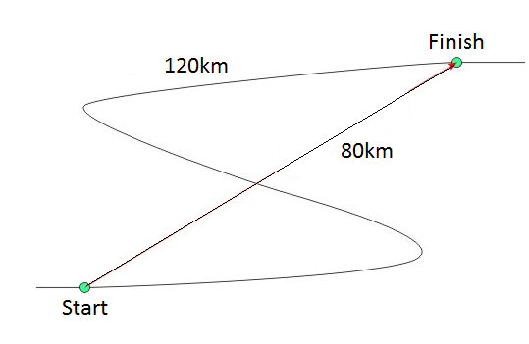***19.** The distance travelled is:

(a) 120km.

(b) 40km.

(c) 80km.

(d) 200km.

**20.** Choose the correct statement below.

(a) The distance is greater than the displacement.

(b) The displacement is greater than the distance.

(c) The distance and displacement are the same.

(d) The displacement is sometimes a straight line distance and direction.

**Short Answer**

**1** Classify the following as situations in which forces are balanced or unbalanced: (4 Marks)

a) A motorbike is accelerating away from traffic lights. \_\_\_\_\_\_\_

b) A car is travelling at 100 km/h straight down a freeway. \_\_\_\_\_\_

c) A surfer falls off their surfboard. \_\_\_\_\_\_

d) A bird flies into a window and bounces off. \_\_\_\_\_\_\_

**2** Calculate the average acceleration of a car that began traveling at 40km/h at 1.00 pm. The car’s speed reached 100km/h at 1.10pm. Show your working.

(2 marks)

**3.** Contrast distance and displacement.

(2 marks)

\_\_\_\_\_\_\_\_\_\_\_\_\_\_\_\_\_\_\_\_\_\_\_\_\_\_\_\_\_\_\_\_\_\_\_\_\_\_\_\_\_\_\_\_\_\_\_\_\_\_\_\_\_\_\_\_\_\_\_\_\_\_\_\_\_\_\_\_\_\_\_\_\_\_\_\_\_\_\_\_\_\_\_\_\_\_\_\_\_\_\_\_\_\_\_\_\_\_\_\_\_\_\_\_\_\_\_\_\_\_\_\_\_\_\_\_\_\_\_\_\_\_\_\_\_\_\_\_\_\_\_\_\_\_\_\_\_\_\_\_\_\_\_\_\_\_\_\_\_\_\_\_\_\_\_\_\_\_\_\_\_\_\_\_\_\_\_\_\_\_\_\_\_\_\_\_\_\_\_\_\_\_\_\_\_\_\_\_\_\_\_\_\_\_\_\_\_\_\_\_\_\_\_\_\_\_\_\_\_\_\_\_\_\_\_\_\_\_\_\_\_\_\_\_\_\_\_\_\_\_\_\_\_\_\_\_\_\_\_\_\_\_\_\_\_\_\_\_\_\_\_\_\_\_\_\_\_\_\_\_\_\_\_\_\_\_\_\_\_\_\_\_\_\_\_\_\_\_\_\_\_\_\_\_\_\_\_\_\_\_\_\_\_\_\_\_\_\_\_\_\_\_\_\_\_\_\_\_\_\_\_\_\_\_\_\_\_\_\_\_\_\_\_\_\_\_\_\_\_\_\_\_\_\_\_\_\_\_\_\_\_\_\_\_\_\_\_\_\_\_\_\_\_\_\_\_\_\_\_\_\_\_\_\_\_\_\_\_\_\_\_\_\_\_\_

**4.** Mr Lafferty walked around the park as shown in the diagram below.

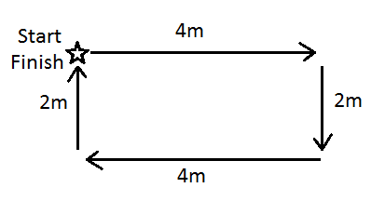

a) Calculate Mr Lafferty’s distance. (1 mark)

\_\_\_\_\_\_\_\_\_\_\_\_\_\_\_\_\_\_\_\_\_\_\_\_\_\_\_\_\_\_\_\_\_\_\_\_\_\_\_\_\_\_\_\_\_\_\_\_\_\_\_\_\_\_\_\_\_\_\_\_\_\_\_\_\_\_\_\_\_\_\_\_\_\_\_\_\_\_\_\_\_

b) Calculate Mr Lafferty’s displacement. (1 mark)

\_\_\_\_\_\_\_\_\_\_\_\_\_\_\_\_\_\_\_\_\_\_\_\_\_\_\_\_\_\_\_\_\_\_\_\_\_\_\_\_\_\_\_\_\_\_\_\_\_\_\_\_\_\_\_\_\_\_\_\_\_\_\_\_\_\_\_\_\_\_\_\_\_\_\_\_\_\_\_\_\_

**5.** Jade rides her bike with a constant speed of 7m/s. It takes 240 seconds to get to school. Calculate how far away school is. (2 marks)

**SHOW ALL OF YOUR WORKING OUT.**

Distance= average speed x time d = v x t

d= v= t=

**6.** This table shows the speed of a man driving a car over time.

|  |  |
| --- | --- |
| **Speed of car (m/s)** | **Time (s)** |
| 5 | 2 |
| 30 | 4 |
| 28 | 6 |
| 10 | 8 |
| 5 | 10 |

Draw a graph using the information from the table above. (5 marks)

REMEMBER all the things that a graph needs!

[](http://www.google.com.au/url?sa=i&rct=j&q=graph+paper&source=images&cd=&cad=rja&uact=8&docid=bnDyK-WDEHhooM&tbnid=OH_xw5ZTcFEuvM:&ved=0CAUQjRw&url=http://virtualmathtutor.blogspot.com/2010/11/how-to-draw-circle-without-compass.html&ei=RKw4U5fxF8fClQWCrIGoCQ&psig=AFQjCNHahbsWAgdANQM5RZCXw4z48cLLBw&ust=1396309252654415)

Describe what happened to the car over the time period. (2 marks)

\_\_\_\_\_\_\_\_\_\_\_\_\_\_\_\_\_\_\_\_\_\_\_\_\_\_\_\_\_\_\_\_\_\_\_\_\_\_\_\_\_\_\_\_\_\_\_\_\_\_\_\_\_\_\_\_\_\_\_\_\_\_\_\_\_\_\_\_\_\_\_\_\_\_\_\_\_\_\_\_\_\_\_\_\_\_\_\_\_\_\_\_\_\_\_\_\_\_\_\_\_\_\_\_\_\_\_\_\_\_\_\_\_\_\_\_\_\_\_\_\_\_\_\_\_\_\_\_\_\_\_\_\_\_\_\_\_\_\_\_\_\_\_\_\_\_\_\_\_\_\_\_\_\_\_\_\_\_\_\_\_\_\_\_\_\_\_\_\_\_\_\_\_\_\_\_\_\_\_\_\_\_\_\_\_\_\_\_\_\_\_\_\_\_\_\_\_\_\_\_\_\_\_\_\_\_\_\_\_\_\_\_\_\_\_\_\_\_\_\_\_\_\_\_\_\_\_\_\_\_\_\_\_\_\_\_\_\_\_\_\_\_\_\_\_\_\_\_\_\_\_\_\_\_\_\_\_\_\_\_\_\_\_\_\_\_\_\_\_\_\_\_\_\_\_\_\_\_\_\_\_\_\_\_\_\_\_\_\_\_\_\_\_\_\_\_\_\_\_\_\_\_\_\_\_\_\_\_\_\_\_\_\_\_\_\_\_\_\_\_\_\_\_\_

END OF TEST

**SOLUTIONS**

**Multiple Choice Answer Sheet**

1. A B C D

2. A B C D

3. A B C D

4. A B C D

5. A B C D

6. A B C D

7. A B C D

8. A B C D

9. A B C D

10. A B C D

11. A B C D

12. A B C D

13. A B C D

14. A B C D

15. A B C D

16. A B C D

17. A B C D

18. A B C D

19. A B C D

20. A B C D

**Short Answer**

**1.** Classify the following as situations in which forces are balanced or unbalanced: (4 Marks)

a A motorbike is accelerating away from traffic lights. Unbalanced

b A car is travelling at 100 km/h straight down a freeway. Balanced

c A surfer falls off their surfboard. Unbalanced

d A bird flies into a window and bounces off. Unbalanced

**2.** (2 Marks)

**3.** Distance refers to the total amount of distance travelled by an object from start to finish. Displacement is the distance of a straight line from the starting point to the end point.

**4.** Mr Lafferty walked around the park as shown in the diagram below.

a) Calculate Mr Lafferty’s distance. (1 mark)

12m (0.5 for 2 , 0.5 for m)

b) Calculate Mr Lafferty’s displacement. (1 mark)

2m North (0.5 for 2m, 0.5 for North)

**6.** Jade rides her bike with a constant speed of 7m/s. It takes 240 seconds to get to school. Calculate how far away school is. (2 marks)

**SHOW ALL OF YOUR WORKING OUT.**

Distance= average speed x time d = v x t

d= ? v= 7m/s t= 240 seconds

d = v x t

d = 7 x 240

d = 1680m

**7.** This table shows the speed of a man driving a car over time.

-1 mark (not in pencil)

-1 mark (not with ruler)

-1 mark (inappropriate title)

-1 mark (axis mixed up)

-1 mark (missing units of measurement)

-1 mark (wrong type of graph)

Speed of Car versus Time

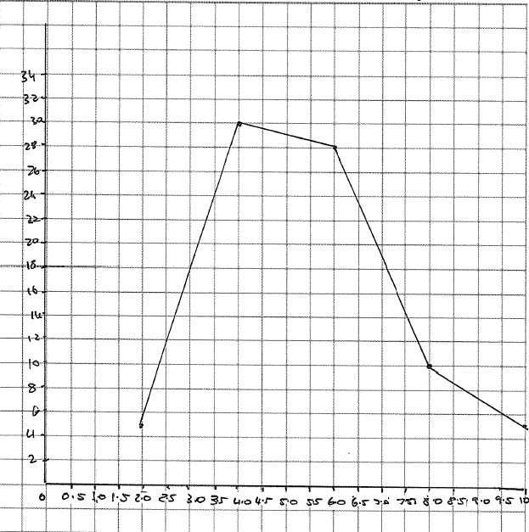

Speed of Car (m/s)

Time (Seconds)

The car speeds up quickly at 4 seconds and then slows down again at 8 seconds (2 marks)